(Approx. 740 words)

What is Disk Defragmentation
By Larry McJunkin
The Retired Geek Technical Tips for the Non-Technical “Over 50” Crowd
http://retiredgeek.net/
http://retiredgeek.net/contact-me/

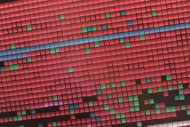
Defragmenting your hard disk is one of the best things you can do to speed up your Windows computer. Think of your hard drive as a file cabinet. If you’re like most people, you have your papers stored in alphabetized folders so you can find things easily.

Imagine, however, if someone took the labels off all the folders, then switched the locations of all the folders, and moved your documents into and out of folders at random. It would take you a lot longer to find anything since you wouldn’t know where your documents were. That’s what happens when your hard drive gets fragmented: it takes your computer much more time to find files which have pieces that are scattered all over your hard drive. Defragmenting your hard drive restores complete order to this mess and speeds up your computer…sometimes a lot.

A Fragmented File on Your Hard Drive

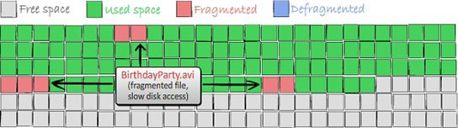

A Defragmented File on Your Hard Drive

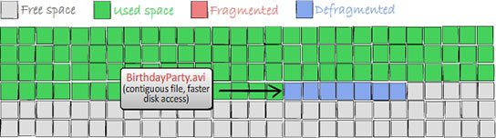
To most people, a file on a computer is something tangible…a thing, a document, a music file, or any other file you may have stored on your hard drive. You would never think of a file as many very small bits of information scattered all over the drive. But Windows (and your hard drive) think differently. To Windows, a file is all these small fragments of information that are kept in various clusters on a hard drive. Windows knows exactly where each fragment of each file is and which is the right order for reading them…that’s how you get your file displayed as a whole. File fragmentation occurs when clusters of free disk space get reused over and over again when you delete old files and save new ones.

Defrags (slang) can be a pain! Primarily, you have to find a time when your computer is on, but you aren’t using it. However, there are good reasons why computer experts keep telling you it needs to be done! The most important of these reasons is that defragmenting your hard drives will help speed up computer performance!

How Hard Drives Become Fragmented



Armed with just what little you’ve read so far, you might wonder why Windows goes through all this hassle whenever you open a file, and why doesn’t it just put the files on your hard drive as complete chunks…thus eliminating the need to defragment. The answer is simple. Because Windows is very space-efficient, and doesn’t want a single bit of hard drive space to be wasted. So when a new file is created (or modified) and saved, it puts pieces of the file in every little nook and cranny it can find.

Just because Windows scatters this information around is not bad…it’s merely inefficient. The only downside of putting file fragments all over the drive is that the drive read needs to do a lot of extra work to find and access all fragments of a file when you want to open it. As a result, fragmented files can often take quite a while to open and what you see is a slow computer.

Defragging is the simple process of re-associating all these file fragments and putting them together in one place to speed up file access. This is the primary reason why you should defragment your hard drive on a regular basis. The least amount of time between defrags the better so you never notice your computer getting slower.

How to Defragment Your Computer

Starting the defrag process varies slightly, dependent upon which version of Windows you have, but the actual process is exactly the same. For Windows 8, when you’re on the Metro (tiled) desktop, simply begin typing “defrag….” and Search will find “Defragment and Optimize Drives”. For Windows XP, Vista and Windows 7 go to the bottom of the Start Menu and in the Search Bar begin typing “defrag….” and you’ll be taken to the defragmenter for your version of Windows.

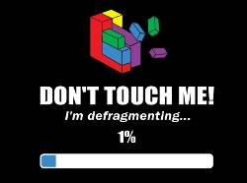
When defragmenting a disk, it’s usually best to leave your computer alone, though if necessary you can use it without messing up anything. Disk Defragmentation might take from several minutes to a few hours to finish, depending on the size and degree of fragmentation of your hard disk. You can still use your computer during the defragmentation process. If you defrag regularly, the time it takes is much shorter.



